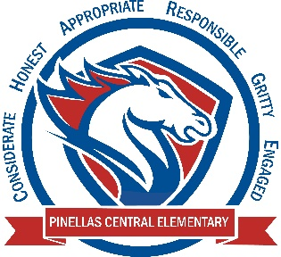

Pinellas Central Elementary School
1st Grade School Supply List 2024-2025

Student Items (for individual student use)
- 1 pair of durable headphones (necessary for computer lab work) - not earbuds
- 1 1½ inch white 3 ring binder with clear pocket cover
- 2 packages of #2 yellow pencils
- 1 three prong two pocket yellow plastic folder
- 1 three prong two pocket green plastic folder
- 1 three prong two pocket red plastic folder
- 1 three prong two pocket blue plastic folder
- 1 box of washable markers
- dry erase markers (black ink)
- backpack

Supplemental Classroom Items-Donations Welcome

- tissues
- gallon and quart sized plastic zipper bags
- antibacterial wipes
- large pink erasers
- disinfectant spray
- paper towels
- 2 packages of durable sheet protectors

- extra dry erase markers (black ink)
- standard sized sticky notes
- band aids
- extra pair of headphones (not earbuds)
- mini post-it easel pad

